

**Tribhuvan University**

**Faculty of Humanities and Social Science**

**PROJRCT REPORT ON**

**YumYum Kitchen**

**Submitted to Department of Computer Application**

**Mega National College**

*In partial fulfilment of the requirement for*

*Bachelors in Computer Application*

**Submitted by**

Rabin GC

Sumin Maharjan

BCA 6th Semester

Under the Supervision of

**Prabesh Maharjan**



**Tribhuvan University**

**Faculty of Humanities and Social Sciences**

**Mega National College**

SUPERVISOR’S RECOMMENDATION

I hereby recommend that this project prepared under my supervision by **……………** entitled **“YumYum Kitchen”** in partial fulfillment of the requirements for the degree of Bachelors of Computer Application is recommended for the final evaluation.

**……………………………**

**SUPERVISOR**

Mega National College

Kumaripati, Lalitpur



**Tribhuwan University**

**Faculty of Humanities and Social Science**

**Mega National College**

**LETTER OF APPROVAL**

This is to certify that this project prepared by Sumin Maharjan and Rabin GC entitled “YumYum Kitchen**”** in partial fulfillment of the requirements for the degree of Bachelor in Computer Application has been evaluated. In our opinion it is satisfactory in the scope and quality as a project for the required degree.

|  |  |
| --- | --- |
| …………………………………………  **SIGNATURE of Supervisor**  Prabesh Maharjan  Mega National College  Kumaripati, Lalitpur | ………………………………………….  **SIGNATURE of HOD/ Coordinator**  Lok Nath Chapagai  Mega National College  Kumaripati, Lalitpur |
| **……………………………………….**  **Signature of Internal Examiner** | **…………………………………….**  **Signature of External Examiner** |

# ABSTRACT

A recipe manager business provides a digital platform for users to organize, manage, and share their recipe collections. The business can generate revenue through various monetization models, such as subscription-based pricing, advertising, or commission on sales of cooking-related products.

The advantages of a recipe manager business include providing a convenient and accessible way for users to store and organize their recipes, enabling users to easily search and filter their collections, and allowing them to share recipes with friends and family. Additionally, a recipe manager business can offer features like meal planning, grocery list creation, and nutritional information to further enhance the user experience. However, the recipe manager market is highly competitive, with numerous established players already in the space, such as Yummly, Big Oven, and Paprika. To be successful, a new recipe manager business will need to differentiate itself through unique features, user-friendly design, and effective marketing. It may also require a significant investment in technology and talent to develop and maintain a robust platform.

An online tutoring service provides a platform for students to connect with qualified tutors for personalized online tutoring sessions. The business can generate revenue through subscription-based pricing, commission on tutor earnings, or a percentage of student fees. The advantages of an online tutoring service include offering flexibility and convenience for both students and tutors, providing a wider range of subject areas and specialized tutors, and potentially reaching a global audience. However, the market is highly competitive, and the business will need to ensure the quality of the tutoring sessions, develop effective marketing strategies, and invest in technology to create a seamless platform.

# ACKNOWLEGMENT

In the accomplishment of this project successfully, many people have best owned upon their blessing and the heart pleased support, this time we are utilizing to thank all the people who have been concerned with this project.

We will like to extend our sincere thanks to Tribhuwan University for giving us the golden opportunity in enhancing our hidden capabilities. Our next thanks will be given to the Mega National College who helps us by giving the perfect environment for learning and for proper infrastructure. The list also includes the Co-Ordinator of Bachelor Department Prabesh Maharjan, And, also to our Head of Department Mr. Lok Nath Chapagai.

Unfortunately, we address several difficulties in coordinating the activities of the project but we are highly indebted to Mr. Prabesh Maharjan for his guidance and constant supervision, as well as the providing necessary information regarding the project and also for his support in completing the project.

Last but not least we would like to thank to my classmates who helped us a lot to support us during making of this project.

With Regards

Sumin Maharjan

TU Registration No: 6-2-925-205-2019

Rabin GC

TU Registration No: 6-2-925-195-201

**TABLE OF CONTENTS**

ABSTRACT iv

ACKNOWLEGMENT v

CHAPTER 1: INTRODUCTION 1

1.1 Introduction of the Project 1

1.2 Statement of Problem 1

1.3 Objective 2

1.4 Applications and Project Features 2

1.4.1 Applications 2

1.4.2 Project Features 2

1.5 System Requirements 3

1.5.1 Hardware Requirements 3

1.5.2 Software Requirements 3

1.6 Report Organization 3

CHAPTER 2: LITERATURE REVIEW 4

2.1 Literature Survey: Existing System 4

2.1.1 Example of Existing System(BigOvan) 5

CHAPTER 3: SYSTEM ANALYSIS AND DESIGN 6

3.1 System Analysis 6

3.2 Requirement Analysis 6

3.2.1 Functional Requirement 6

3.2.2 Non-Functional Requirement 7

3.3 Feasibility Analysis 7

3.3.1 Technical Feasibility 8

3.3.2 Operational Feasibility 8

3.3.3 Economic Feasibility 8

3.3.4 Scheduling Feasibility 9

3.4 Structuring System Requirements 9

3.4.1 Data Modeling (ER Diagram) 9

3.4.2 Context Diagram 11

3.4.3 Use Case Diagram 12

3.5 System Design 13

3.5.1 Architecture Design 14

3.5.2 Database Schema 14

CHAPTER 4: CONCUSION AND FUTURE RECOMMENDATION 16

5.1 Lesson learnt/ Outcome 16

5.2 Conclusion 16

5.3 Future Recommendation 17

REFERENCES 18

# List of figure

Figure 3.1: Gantt Chart 9

Figure 3.3: Context Diagram 11

Figure 3.4: Use Case Diagram 12

Figure 3.6: Architecture of Exam Management System 14

Figure 3.7: Database Schema Design 15

# CHAPTER 1: INTRODUCTION

## 1.1 Introduction of the Project

A recipe manager is a software application or platform designed to help users organize, manage, and store their recipe collections. It provides a digital platform for users to search, store, and share their favorite recipes. Recipe managers can offer a variety of features, such as meal planning, grocery list creation, nutritional information, and cooking tips.

Recipe managers are becoming increasingly popular as more people turn to digital platforms to manage their daily tasks and routines. With the rise of cooking blogs, social media, and food-centric websites, there is an abundance of online recipes available. Recipe managers help users navigate this vast landscape of online recipes and organize their favorite recipes in one convenient location.

The benefits of using a recipe manager include easy access to all of your recipes, the ability to search and filter recipes by ingredients or tags, the ability to create meal plans and grocery lists based on your recipes, and the ability to share recipes with friends and family.

Overall, a recipe manager provides a convenient and efficient way for users to manage their recipe collections and enhance their cooking experience., images, and specifications to help you make informed purchasing decisions

## 1.2 Statement of Problem

Cooking is a popular activity that has become more popular over the years, especially with the rise of food bloggers and online recipes. However, with so many recipes available online, it can be difficult for home cooks to keep track of their favorite recipes, especially when they are spread across multiple websites or physical sources. This can lead to frustration, wasted time, and even the loss of cherished family recipes.

Furthermore, many home cooks struggle with meal planning and grocery shopping, often resorting to last-minute decisions that can be both stressful and unhealthy.

## 1.3 Objective

The main goals of a recipe manager are to:

Save time and reduce stress for home cooks by providing a centralized location for all of their favorite recipes, making it easier to find and access them when needed.

Simplify meal planning and grocery shopping by offering features such as meal planning, grocery list creation, and the ability to generate shopping lists based on recipes.

Promote healthy eating habits by providing nutritional information for recipes and allowing users to filter recipes based on dietary restrictions or preferences.

Foster a sense of community by allowing users to share their recipes with friends and family, and discover new recipes from other users.

Overall, the objective of a recipe manager is to enhance the cooking experience for home cooks, making it easier and more enjoyable to prepare meals and try out new recipes.

## 1.4 Applications and Project Features

### 1.4.1 Applications

Application of this project is very broad in terms of otherRecipe Manager sites

YumYum Kitchen is basically designed for easy availability of recipe of food anytime anywhere.

### 1.4.2 Project Features

Develops a system which allows the faculty to add, modify and view the recipes.

It has the features likerating the recipe of foods including review, complain.

* Time saver
* Compatible with laptop and desktop computers.

## 1.5 System Requirements

### 1.5.1 Hardware Requirements

Laptop or desktop computer having RAM:2 GB or more

Hard Drive:5 GB or more

### 1.5.2 Software Requirements

Tools I have used for:

**Front End**

* Html
* CSS
* Bootstrap
* JavaScript

**Back End**

* JDBC Connection
* MySQL Database

## 1.6 Report Organization

This report document contains five chapters including this chapter. Chapter two defines and describes over view of related existing system. Chapter three presents the System Analysis and Design including Requirement Analysis and Feasibility Analysis. Chapter four presents the Implementation and Testing are explained. In chapter five Lesson Learnt, Conclusion and Future Enhancement are briefly explained.

# CHAPTER 2: LITERATURE REVIEW

## 2.1 Literature Survey: Existing System

Recipe managers have become increasingly popular in recent years as more people turn to digital platforms to organize their lives. The concept of a recipe manager is not new, as home cooks have been using recipe boxes and cookbooks for decades to keep track of their favorite recipes. However, with the rise of the internet and social media, the number of recipes available has exploded, making it difficult for home cooks to keep track of all their favorite recipes

Recent studies have shown that using a recipe manager can save time, reduce stress, and improve the overall cooking experience. A survey of home cooks found that those who used a recipe manager reported feeling more organized and less stressed when cooking meals. Additionally, a study of college students found that those who used a recipe manager had healthier eating habits than those who did not, suggesting that recipe managers can help promote healthy eating habits.

Recipe managers offer a variety of features that can help home cooks manage their recipe collections, such as search and filter capabilities, meal planning and grocery list creation, and nutritional information. These features can help home cooks save time and reduce food waste, as well as make it easier to try out new recipes and experiment with different cuisines.

Overall, the literature suggests that recipe managers can be a valuable tool for home cooks, providing a centralized location for all their favorite recipes and making it easier to plan meals and grocery shopping. Recipe managers can also promote healthy eating habits and foster a sense of community among home cooks who share and discover new recipes through the platform.

### 2.1.1 Example of Existing System(BigOvan)

Oven was started by a software veteran who loves to cook. Steve was standing in a grocery store in 2003, wishing he could look up his family recipes, as well as a vast cookbook of options to make the most of what was freshest that day. We are a welcoming home cook community that shares the same passion for being in the kitchen as you do.

With BigOven, you can take your recipes anywhere, make grocery lists, reduce food waste and easily share your favorite creations with your friends, family or even your future self when you need them. An innovative leader in its category, BigOven was the first recipe app for iOS and Android devices, and has been downloaded over 13 million times, with over 5 million registered members.

With the introduction of the BigOven Kitchen in 2020, a new intent to provide unique and creative opportunities for audiences to gather around food and capture memories was created and is something that will only continue to evolve and grow over time. This is not just a test kitchen, but a place to play with all kinds of food content and production.

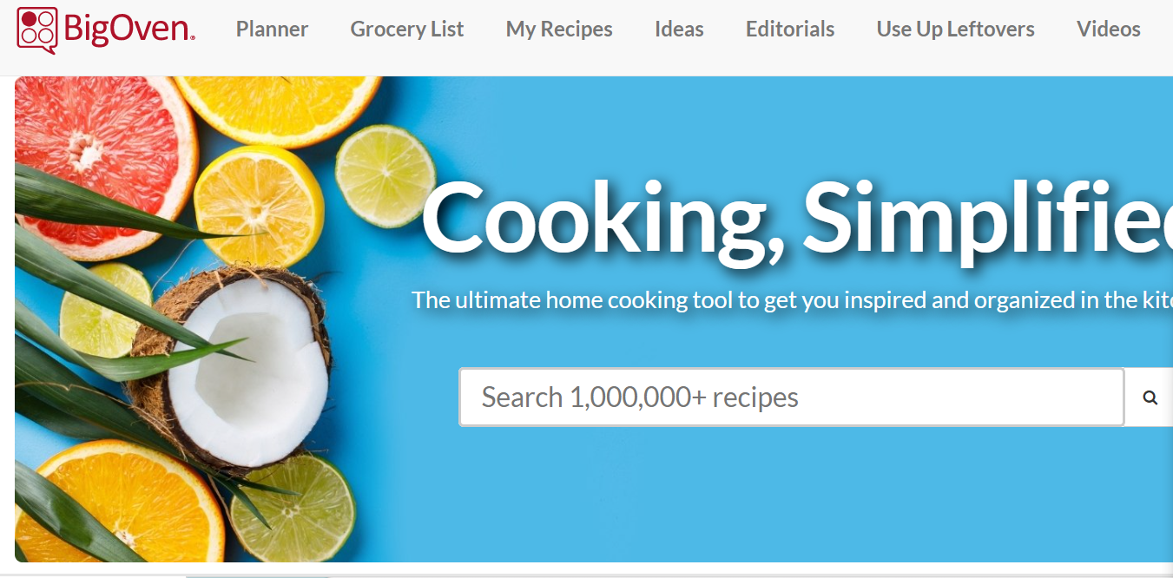Figure 2.1: Bigovan User Interface

# CHAPTER 3: SYSTEM ANALYSIS AND DESIGN

## 3.1 System Analysis

System analysis is conducted for the purpose of studying a system or its parts in order to identify its objectives. It is a problem-solving technique that improves the system and ensures that all the components of the system work efficiently to accomplish their purpose. The large complex project was broken into small manageable parts so each may be designed, studied and analyzed in detail.

## 3.2 Requirement Analysis

To design and develop system, functional as well as non-functional requirement of the system has been studied as given below:

### 3.2.1 Functional Requirement

Functional requirements are nothing but the services provided by the system to its end users.

There are two kinds of user types in this Application.

* Client module
* Fill up the login for re access of data
* Seek over our recipes
* Rating for recipes
* Suggestion

Admin module

* Logging into system.
* Adding, updating, deleting the content.
* Review users complains and suggestion.

### 3.2.2 Non-Functional Requirement

Nonfunctional Requirements (NFRs) define system attributes such as security, reliability, performance, maintainability, and usability. functional requirements define what a system(application) is supposed to do non-functional requirements define how a system(application) is supposed to be. The application must be user-friendly which means customers must not feel difficulty while using it. Non-functional requirements are the criteria for evaluating how an application should perform and an application must have certain quality attributes in order to meet non-functional requirements.

List of non-functional requirements include:

* Usability: This site is easy to use and it is user friendly.
* Reliability: The probability and percentage of the site performing without failure for a specific number of uses or amount of time
* Security: The entire site is very secure.
* Performance: Every feature presented by the site has a quick response time.
* Flexibility: The new feature can be easily added.

## 3.3 Feasibility Analysis

A feasibility study is an analysis that considers all of a project relevant factor including economic, technical, legal and scheduling considerations to ascertain the likelihood of completion the project successfully. Before building the system following feasibilities were studied to determine the viability of the system such as ensuring a project is economically, technically and operationally justifiable.

A feasibility study is simply an assessment of the practicality of a proposed plan or projects. The goals of feasibility studies are as follows:

* To understand thoroughly all aspects of a project, concept, or plan
* To become aware of any potential problems that could occur while implementing the project.

## 3.3.1 Technical Feasibility

Building this system is technically feasible. The hardware and software needed are all available, it not difficult to get them. Brief I can say the necessary resources needed for the development and maintenance of the system are available. I am using java programming languages and database. I am using following tools to create the overall system:

* Java swing (JFrame)
* Html
* Bootstrap
* CSS
* MySQL database

### 3.3.2 Operational Feasibility

The system will be user friendly and all the requirements will be met and the problems identified will be solved. The project I am developing is operationally feasible as there is no need for users to have good knowledge in computer before using it. The user can learn and use the system with easiness; he just needs to read the manual or tutorial from the developers

### 3.3.3 Economic Feasibility

I am using open-source technologies so the system is economically feasible. Extra hardware or software or any other extra expenses will not be there so the system will not have recurring cost. Besides being technically feasible, developing this system is economically feasible as well. The development of the system does not require the developers to spend a lot of money. The tools I am using to develop the system are not expensive and the software’s are open source. All I need is time. The system is indeed economically feasible.

### 3.3.4 Scheduling Feasibility

This feasibility is the most important for project success. The project will fail if it is not completed on time. This feasibility estimates how much time the project will take to complete. This feasibility is to find out the estimate how long the system will take to develop, complete and how reasonable the project timetable is.

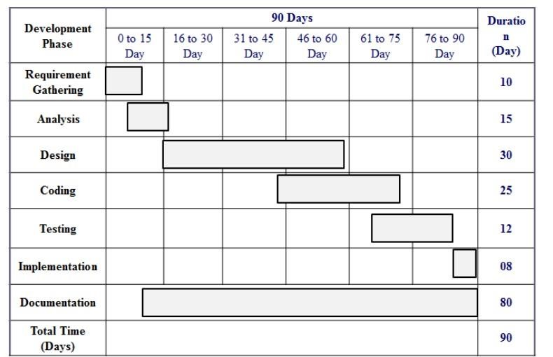

Figure 3.1: Gantt Chart

## 3.4 Structuring System Requirements

UML has been used as visual modeling language. Some of the tools used are ER diagram for data modeling technique, DFD diagram for process modeling and Use case diagram for analyzing functional requirement.

## 3.4.1 Data Modeling (ER Diagram)

An Entity Relationship (ER) Diagram is a type of flowchart that illustrates how “entities” such as people, objects or concepts relate to each other within a system. ER Diagrams are most often used to design or debug relational databases in the fields of software engineering, business information systems, education and research. Also known as ERDs or ER Models, they use a defined set of symbols such as rectangles, diamonds, ovals and connecting lines to depict the interconnectedness of entities, relationships and their attributes.

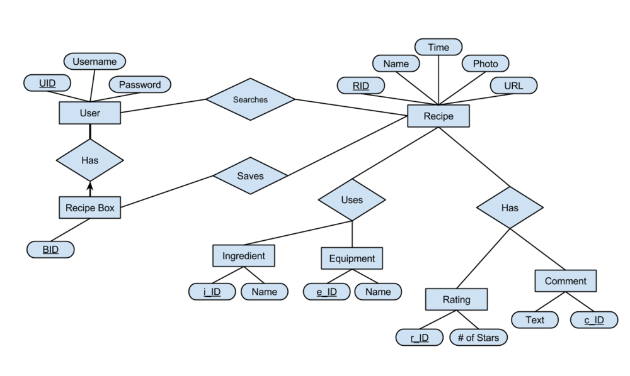Figure 3.2: ER Diagram

### 3.4.2 Context Diagram

A context diagram, sometimes called a level 0 data-flow diagram, is drawn in order to define and clarify the boundaries of the software system. It identifies the flows of information between the system and external entities. The entire software system is shown as a single process.

The Context Diagram shows the system under consideration as a single high-level process and then shows the relationship that the system has with other external entities (systems, organizational groups, external data stores, etc.

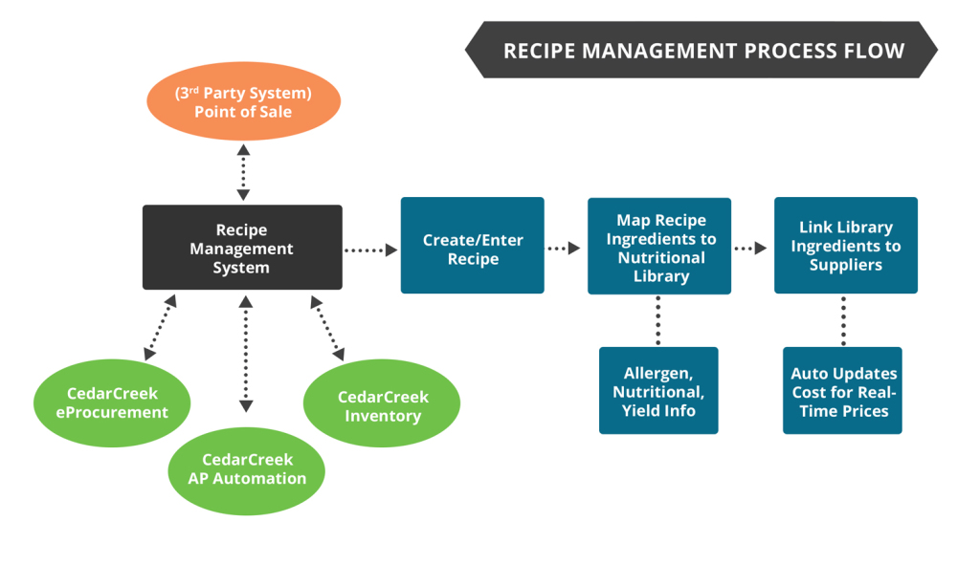

Figure 3.3: Context Diagram

### 3.4.3 Use Case Diagram

In the Unified Modeling Language (UML), a use case diagram can summarize the details of your system's users (also known as actors) and their interactions with the system. An effective use case diagram can help your team discuss and represent:

Scenarios in which your system or application interacts with people, organizations, or external systems

Goals that your system or application helps those entities (known as actors) achieve

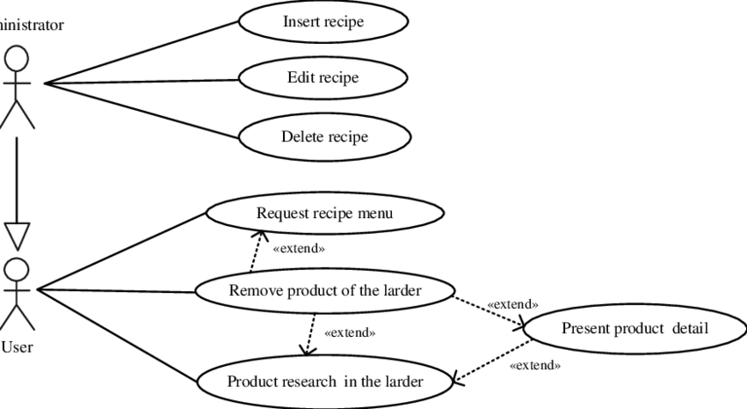

Figure 3.4: Use Case Diagram

## 3.5 System Design

In this step Software Requirement Specification document is converted into a format that helped to decide how the app will operate. It focuses on the solution domain and practical implementation. Here, the complex activity of app development is divided into several smaller sub-activities, which coordinate with each other to achieve the main objective of app.

The methodology chosen to develop this system is waterfall model approach. I opted for this method because I found that it is the best for my project where the stages involved can assist my level of progress. Many developers prefer waterfall model and widely use it as a development strategy. Waterfall model approach is chosen because the approach allows the development of the system to be revised after the stages is finished. Once the stages are not satisfied, then going back to the previous stages can be considered necessary to add or modify any features.

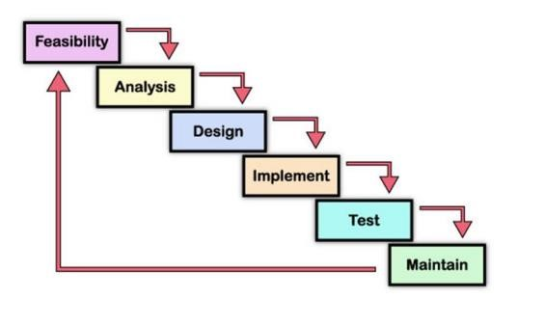Figure 3.5: Waterfall Model

### 3.5.1 Architecture Design

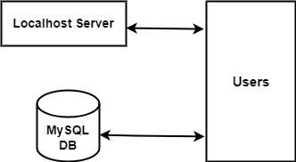

Figure 3.6: Architecture of Exam Management System

### 3.5.2 Database Schema

A recipe manager is a software application that is used to store, organize, and manage recipes. A typical data schema for a recipe manager may include the following entities:

* Recipe: This entity represents a recipe, which includes information such as the recipe name, ingredients, cooking instructions, cooking time, serving size, and nutritional information.
* Ingredient: This entity represents an ingredient, which includes information such as the ingredient name, measurement unit, and a list of recipes that use this ingredient.
* Category: This entity represents a category of recipes, which includes information such as the category name, a list of recipes in this category, and a description of the category.
* User: This entity represents a user of the recipe manager application, which includes information such as the user's name, email address, and password.
* Recipe Collection: This entity represents a collection of recipes, which includes information such as the collection name, a list of recipes in the collection, and a description of the collection.
* Meal Plan: This entity represents a meal plan, which includes information such as the meal plan name, a list of recipes for each meal of the day, and the date range for the meal plan.

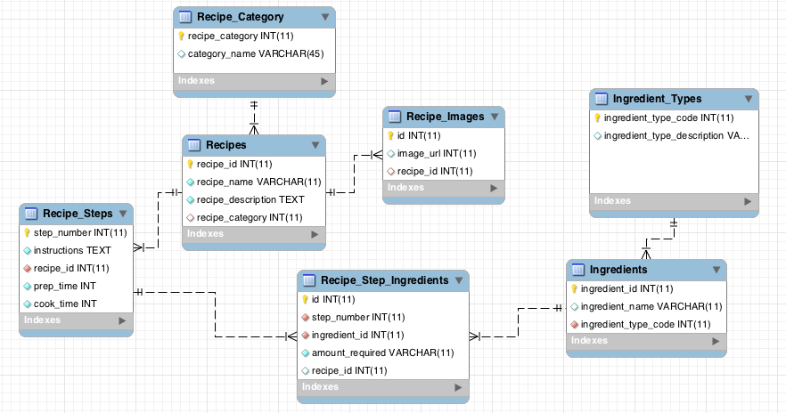

Figure 3.7: Database Schema Design

# CHAPTER 4: CONCUSION AND FUTURE RECOMMENDATION

## 5.1 Lesson learnt/ Outcome

During the time of building this project, I learnt about database design process, project development process and also learned more about various programming techniques.

When the project is completed, Admin have all the controls i.e. register new recipe, add, view, delete and update recipes. Users will be able to views the recipe and suggest.

## 5.2 Conclusion

As my project has reached completion, I have built a simple good-looking easy to use application. My goal was to create an application where faculty creates tests and also generate results after attending the exam by students. The current application can be used for various evaluation purpose.

Building this application has been challenging and enriching because throughout the project I learnt about MySQL, Java applet and swing which are open source and freely available and it successfully solve the problem of manual objective examination system. The proposed system is useful for user with minimal IT knowledge. Towards the end of project, it was discovered that the application might benefit from a number of improvements. Any more enhancements to the application can be made during future development.

## 5.3 Future Recommendation

**I**n the future, recipe managers are likely to become even more advanced, with features such as:

Integration with smart kitchen appliances: Recipe managers may be able to communicate with smart appliances like ovens and stovetops, allowing for precise temperature control and automatic cooking times.

Personalized recommendations: Using artificial intelligence and machine learning, recipe managers may be able to offer personalized recommendations based on the user's preferences and past behavior.

Social sharing: Users may be able to share their favorite recipes with friends and family on social media platforms, as well as browse and discover new recipes shared by others.

Voice control: With the increasing popularity of voice assistants like Amazon Alexa and Google Assistant, recipe managers may incorporate voice control, allowing users to search for and access recipes hands-free.

Augmented reality: Recipe managers may use augmented reality technology to provide step-by-step instructions and help users visualize the cooking process.

Overall, recipe managers are likely to continue to evolve and become even more sophisticated, providing users with more personalized and intuitive ways to manage their recipe collections and make delicious meals at home

# REFERENCES

[1] [Online]. Available: https://bcanotesnepal.com/bca-fourth-semester-project-sample-fotproject-i-bca-tu/.

[2] Z. M. Wang, G. R. Arce, and G. Di Crescenzo, “Halftone visual cryptography via direct binary search”, Proc. EUSIPCO’06, Florence, Italy, Sep. 2006

[3] T. M. Alkharobi, A. K. Alvi, “New Algorithm For Halftone Image Visual Cryptography”, *IEEE 2004*

[4] Y.-C. Hou, “Visual cryptography for color images”, *Pattern Recognition*, vol. 36, iss. 7, pp. 1619–1629, 2003

[5] M. Nakajima and Y. Yamaguchi, “Extended visual cryptography for natural images,” *Proc. WSCG Conf. 2002*, pp. 303–412, 2002

[6] Y.-C. Zeng and C.-H. Tsai "Controllable transparency image sharing scheme for grayscale and color images with unexpanded size", *Signal and Information Processing Association Annual Summit and Conference (APSIPA), 2013 Asia-Pacif*, pp. 1-4, 2013